**Exercise 2: Implementing the Factory Method Pattern**

Document.java

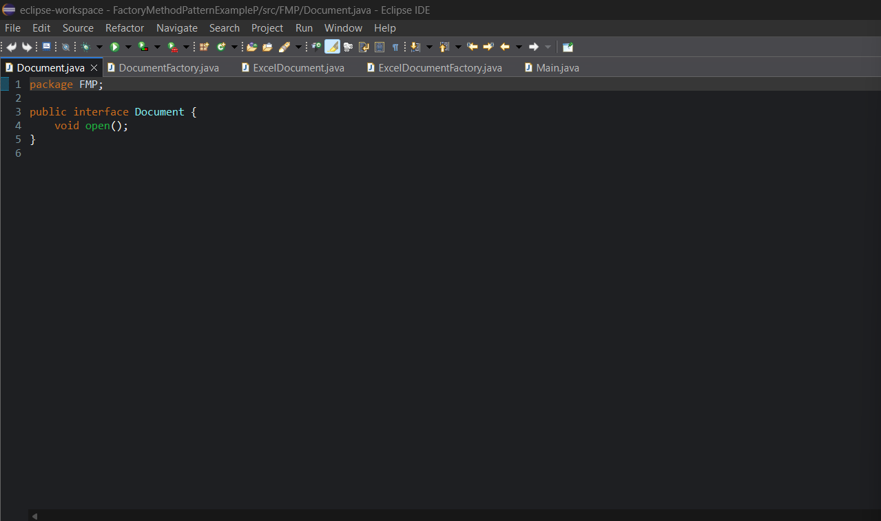

DocumentFactory.java

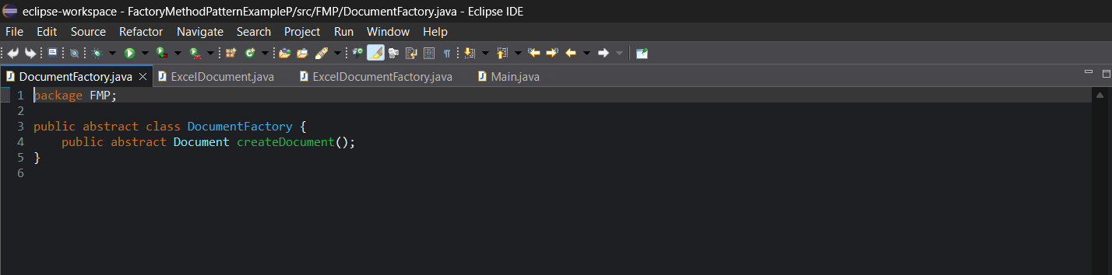

ExcelDocumentary.java

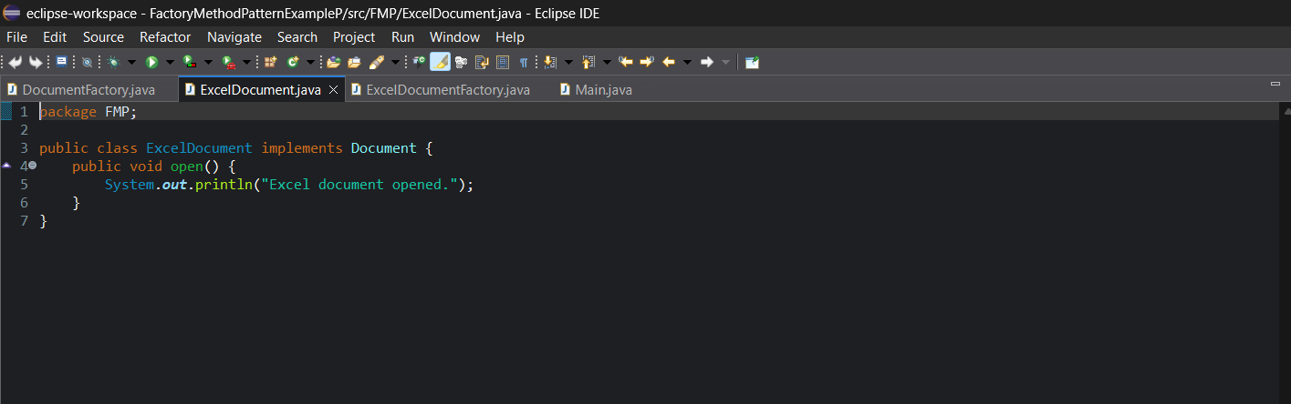

ExcelDocumentFactory.java

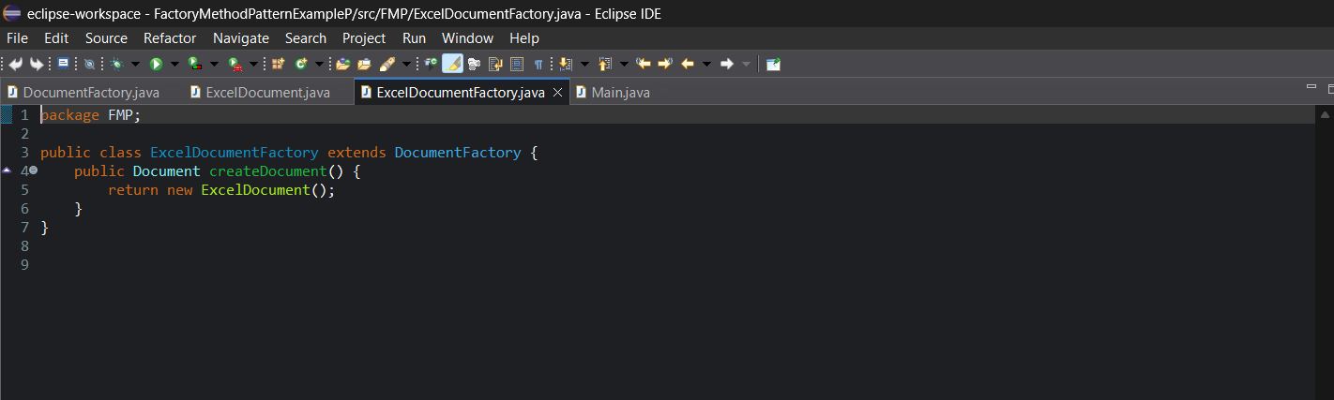

PdfDocumentary.java

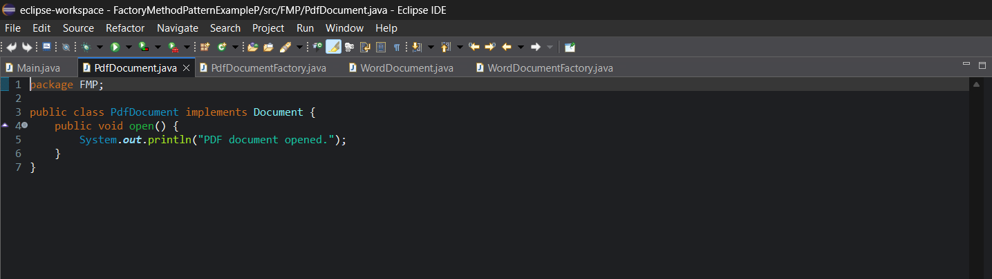

PdfDocumentFactory.java

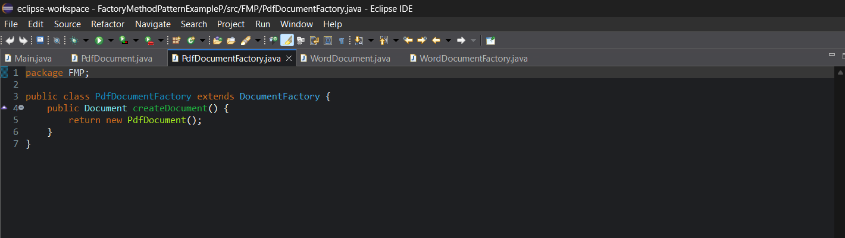

WordDocument.java

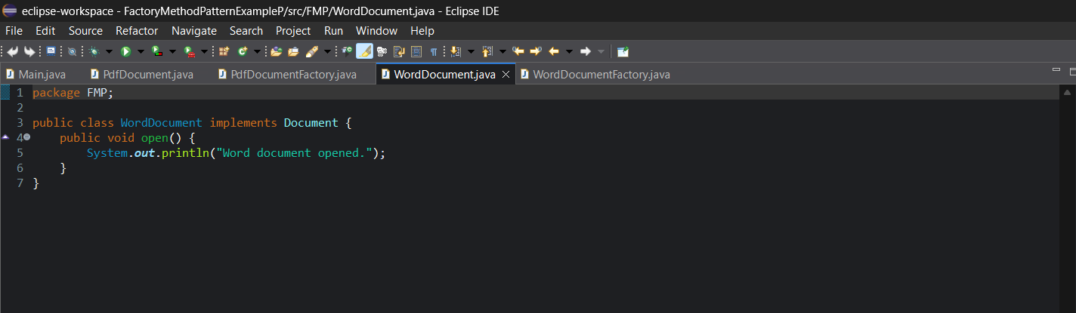

WordDocuementFactory.java

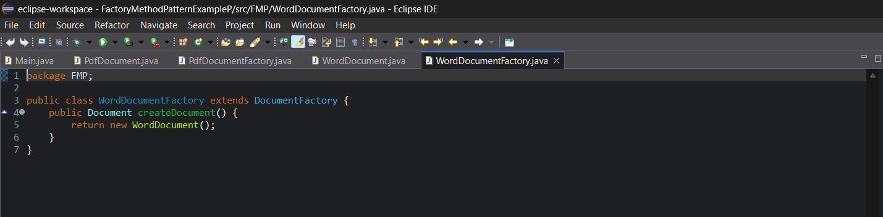

Main.java

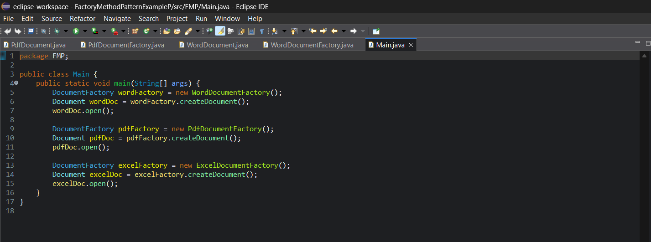

**Output**:   
  
